**Calculator Assumed**

**Binomial Distribution**

Time: 45 minutes

Total Marks: 45

Your Score: / 45



**Question One: [2, 2, 2, 2, 2, 2 = 12 marks] CA**

State whether each of the following scenarios can be suitably modelled by a Bernoulli random variable.

For those that can, calculate the associated probability.

(a) The probability of two boys in a 3 child family.

(b) The probability of rolling two prime numbers in two successive rolls of a normal six sided dice.

(c) The chance of selecting a red marble, and then a blue marble from a bag containing 5 red marbles, 2 blue marbles and 7 green marbles.

(d) The chance of obtaining a sum greater than 7 when rolling two dice and adding the two uppermost faces.

(e) The probability of Perth Glory winning 5 successive games if their chance of winning each game increases by 10%. The probability of them winning the first game is 0.4.

(f) The probability of Perth Glory winning 3 out of 5 games if their chance of winning each game is 0.6.

**Question Two: [3 marks] CA**

A random variable *X* is such that  .

Determine the value of *p* given that 

**Question Three: [1, 1, 2, 2, 3 = 9 marks] CA**

Studies in Britain have recorded that 1 in 100 eight year-old children need at least one tooth removed caused by sugary drinks and severe tooth decay.

A typical primary school class of 24 eight year-olds are investigated for the need to remove at least one tooth.

Determine the probability of:

(a) 2 students needing at least one tooth removed.

(b) No students requiring the removal of any teeth.

(c) At least one student requiring the removal of at least one tooth.

(d) Less than 4 students requiring the removal of at least one tooth given that at least one student required tooth removal.

Of the thirteen year-olds in Britain requiring tooth removal, the probability of them requiring just one tooth out of their 32 permanent teeth removed is 5%.

(e) Calculate the probability of a permanent tooth in a thirteen year - old needing removal.

**Question Four: [4 marks] CA**

The graph below shows a binomial probability distribution. Find the value of *n*, the

number of independent trials, and *p*, the probability of success on just one trial.

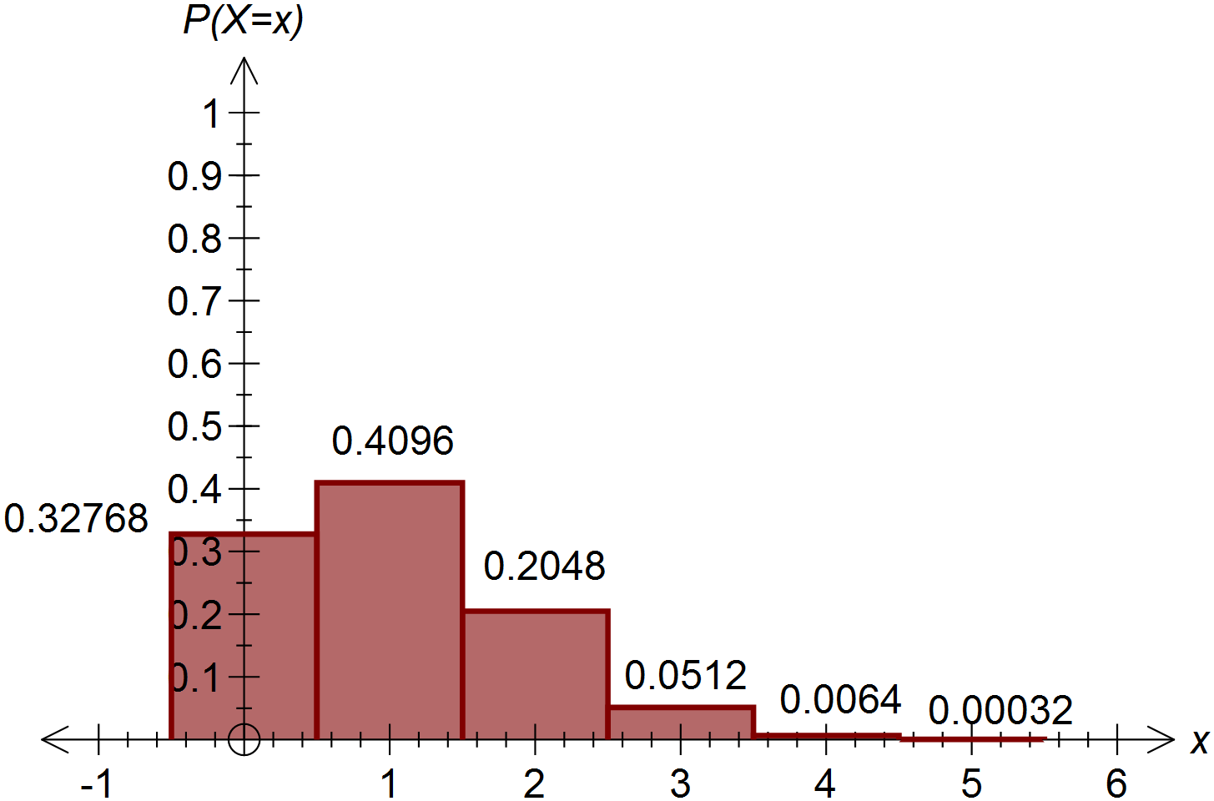

**Question Five: [2, 1, 1 = 4 marks] CA**

(a) Use Pascal’s triangle, or otherwise, to write down the expansion of .

(b) If *b* is the probability of a success in a Bernoulli trial, which term of the expansion corresponds to the probability of 5 successes?

(c) State the relationship between *a* and *b* if *b* is the probability of a success in a Bernoulli trial and *a* is the probability of a failure.

**Question Six: [2, 2, 2, 2, 4, 1 = 13 marks] CA**

Phoebe and Katelyn are facing a multiple choice assessment for their least favourite subject.

Marks for this test will be awarded in the following way: 4 marks will be awarded for a correct answer, 0 marks will be awarded for not attempting a question and 2 marks will be deducted for an incorrect answer.

This assessment contains 20 questions, each with four alternative answers.

Katelyn starts reading the test and is certain she knows 6 of the answers.

(a) If Katelyn attempts all questions, what is the chance she’ll answer 15 out of 20 correctly?

(b) If Katelyn attempts all questions, what is the most likely number of questions she’ll answer correctly?

Phoebe starts reading the test and is certain she knows 10 of the answers.

She has two strategies to employ, detailed below.

Strategy A: Answer the 10 questions she knows for certain and guess the other 10.

Strategy B: Answer the 10 questions she knows for sure and guess 6 of the other 10 questions (thus not attempting 4 questions).

(c) Calculate the expected number of correct questions if Phoebe uses strategy A.

(d) Calculate the expected number of correct questions if Phoebe uses strategy B.

(e) Hence calculate the number of marks she can expect to be awarded with each strategy.

(f) Which strategy should Phoebe use?

**SOLUTIONS**

**Calculator Assumed**

**Binomial Distribution**

Time: 45 minutes

Total Marks: 45

Your Score: / 45



**Question One: [2, 2, 2, 2, 2, 2 = 12 marks] CA**

State whether each of the following scenarios can be suitably modelled by a Bernoulli random variable.

For those that can, calculate the associated probability.

(a) The probability of two boys in a 3 child family.

Yes, this can be modelled by a Bernoulli random variable – 2 boys out of three children is considered a success, in any order. The probability of being born a boy remains constant.

 

(b) The probability of rolling two prime numbers in two successive rolls of a normal six sided dice.

 Yes this can be modelled by a Bernoulli trial since on each roll of the dice, the probability of rolling a prime number remains constant and each roll is independent of the first.

 

(c) The chance of selecting a red marble, and then a blue marble from a bag containing 5 red marbles, 2 blue marbles and 7 green marbles.

 No this cannot be modelled by a Bernoulli trial since there are three possible outcomes each time a marble is selected, rather than the two required to conform to a Bernoulli trial (as well as the probabilities not remaining constant).

(d) The chance of obtaining a sum greater than 7 when rolling two dice and adding the two uppermost faces.

 Yes, this can be modelled by a Bernoulli random variable as there are only two outcomes (a sum greater than 7 or less than or equal to 7) and each time the two dice are rolled, the probabilities remain constant and independent.

 

(e) The probability of Perth Glory winning 5 successive games if their chance of winning each game increases by 10%. The probability of them winning the first game is 0.4.

  No this cannot be modelled by a Bernoulli random variable since the probability of winning does not remain constant each game.

(f) The probability of Perth Glory winning 3 out of 5 games if their chance of winning each game is 0.6.

 Yes, this situation can be modelled by a Bernoulli random variable since there are two possible outcomes (winning vs not winning) and the chance of winning each game is independent.



**Question Two: [3 marks] CA**

A random variable *X* is such that  .

Determine the value of *p* given that 



**Question Three: [1, 1, 2, 2, 3 = 9 marks] CA**

Studies in Britain have recorded that 1 in 100 eight year-old children need at least one tooth removed caused by sugary drinks and severe tooth decay.

A typical primary school class of 24 eight year-olds are investigated for the need to remove at least one tooth.

Determine the probability of:

(a) 2 students needing at least one tooth removed.

 

(b) No students requiring the removal of any teeth.

 

(c) At least one student requiring the removal of at least one tooth.

 

(d) Less than 4 students requiring the removal of at least one tooth given that at least one student required tooth removal.

 

Of the thirteen year-olds in Britain requiring tooth removal, the probability of them requiring just one tooth out of their 32 permanent teeth removed is 5%.

(e) Calculate the probability of a permanent tooth in a thirteen year - old needing removal.

 

**Question Four: [4 marks] CA**

The graph below shows a binomial probability distribution. Find the value of *n*, the

number of independent trials, and *p*, the probability of success on just one trial.







**Question Five: [2, 1, 1 = 4 marks] CA**

(a) Use Pascal’s triangle, or otherwise, to write down the expansion of .

 

(b) If *b* is the probability of a success in a Bernoulli trial, which term of the expansion corresponds to the probability of 5 successes?

 

(c) State the relationship between *a* and *b* if *b* is the probability of a success in a Bernoulli trial and *a* is the probability of a failure.



**Question Six: [2, 2, 2, 2, 3, 4 = 13 marks] CA**

Phoebe and Katelyn are facing a multiple choice assessment for their least favourite subject.

Marks for this test will be awarded in the following way: 4 marks will be awarded for a correct answer, 0 marks will be awarded for not attempting a question and 2 marks will be deducted for an incorrect answer.

This assessment contains 20 questions, each with four alternative answers.

Katelyn starts reading the test and is certain she knows 6 of the answers.

(a) If Katelyn attempts all questions, what is the chance she’ll answer 15 out of 20 correctly?

 

(b) If Katelyn attempts all questions, what is the most likely number of questions she’ll answer correctly?



This is the highest probability in the above defined distribution.

Therefore Katelyn is most likely to guess three correctly. Hence she is likely to answer 9 questions correctly, with the 6 she already knows.

Phoebe starts reading the test and is certain she knows 10 of the answers.

She has two strategies to employ, detailed below.

Strategy A: Answer the 10 questions she knows for certain and guess the other 10.

Strategy B: Answer the 10 questions she knows for sure and guess 6 of the other 10 questions (thus not attempting 4 questions).

(c) Calculate the expected number of correct questions if Phoebe uses strategy A.



 Phoebe is therefore expected to answer 12 or 13 answers correctly.

(d) Calculate the expected number of correct questions if Phoebe uses strategy B.

 

 Phoebe is therefore expected to answer 11 or 12 answers correctly.

(e) Hence calculate the number of marks she can expect to be awarded with each strategy.

Strategy A:  OR 

 Strategy B:  OR 

(f) Which strategy should Phoebe use?

Phoebe will earn more marks using Strategy B.